If you are given: The slope and y-intercept If you are given: A Graph

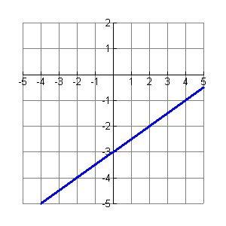
Ex:
Ex:
Slope = ½ and
y-intercept = -3

If you are given: The slope and a point If you are given: Two points

Ex:
Slope = ½ and
point (4,-1)
Ex:
Point (-2, -4)
Point (2, -2)

How to Write the
Equation of a Line

If you are given: If you are given:

The slope and y-intercept A Graph

Fold here
Fold here

If you are given: If you are given:
The slope a Point Two points

