Math Blast From the Past

Pythagoras is often considered the first true ___________________________.

The Pythagoreans were also the first to teach that the ______________ is a Sphere revolving around the ___________.

Pythagoras was born on _____________a Greek island off the coast of Asia Minor.

As a young man, he left his native city for Southern Italy, to escape the _________________ _______________________.

He died in ________________________around _________years old from unknown causes.

Many of Pythagoras’ beliefs reflect those of the ___________________.

___________________________

The sum of the angles of a triangle is equal to two right angles or ___________ degrees.

The abstract quantity of numbers. There is a big step from 2 ships + 2 ships = 4 ships, to the abstract result ____________________.

One of the Pythagoreans’ most important discoveries was that the _____________of the
square is longer than its______________.

(Work the problems on the back of this page)

Name these Regular Solids.

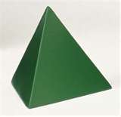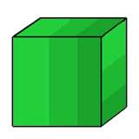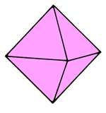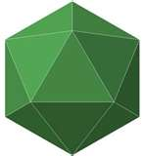

_______________ __________ ______________ ____________ ________________

Measure the net of this regular solid and find the surface area (show all work)

