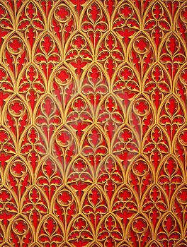
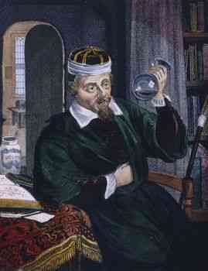
Fully qualified 14 years at university, 7 of those yrs he studied medicine, there always men.



Knowledge: 5
Experience: 5
Cost of treatment: 1
Success rate: 5

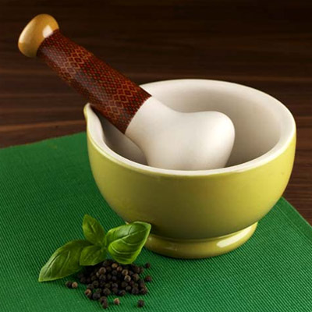
He sells and mixes medicine. Prescribed by physician.

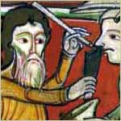

Given licence by bishops. Second class doctors. Looked down on by physicians.
Knowledge: 4
Experience:5
Cost of treatment:2
Success rate:3

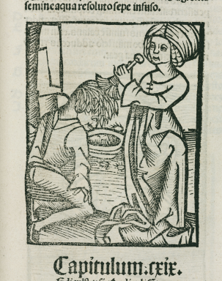

1 in every village, uses herbs from knowledge. If anything wrong happened then she’d be accused of being a witch

Knowledge: 5
Experience:5
Cost of treatment:4
Success rate:3

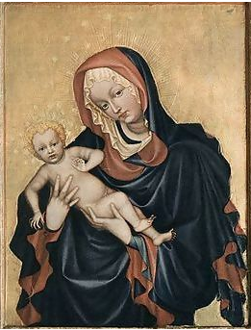

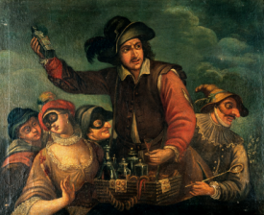
Knowledge: 2
Experience:2
Cost of treatment:4
Success rate:2
Knowledge: 3
Experience:2
Cost of treatment:5
Success rate:3
Unlicensed, was the first to treat her husband and children
They were at fairs and markets. Pulling teeth out, sometimes it was a scam.

