ACTIVITY 1

A. Look at the picture carefully. List down words about the picture (e.g nouns,
verbs) . The first task has been done for you.

2. nurse- standing
1. nurse - holding

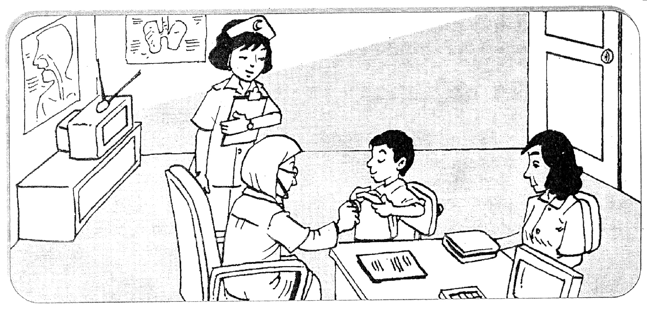
3. boy- pulling up

7. television- cabinet
4. mother- watching

5. room- neat
6. doctor - checking

B. Use the words listed above to form simple sentences in the table given to describe the picture. The first task has been done for you.

Subject | verb | Object/ Complement
Who | do/does what | What where how when
1. A nurse  2. A nurse  3. A boy  4. Mother  5. The room  6. The doctor  7. The television | is holding  is standing  is pulling up  is watching  is  is checking  is | a file.  beside the doctor.  his shirt.  the doctor.  neat.  the boy.  on the cabinet.

C. Copy down the sentences. The first task has been done for you.

1. A nurse is holding a file.

2. A nurse is standing beside the doctor.

3. A boy is pulling up his shirt,

4. Mother is watching the doctor.

5. The room is neat.

6. The doctor is checking the boy.

7. The television is on the cabinet.

ACTIVITY 2

A. Look at the picture carefully. List down words about the picture (e.g nouns,
verbs).

3. two girls - playing

4. man - reading
2. boy - playing
1. boy - jogging

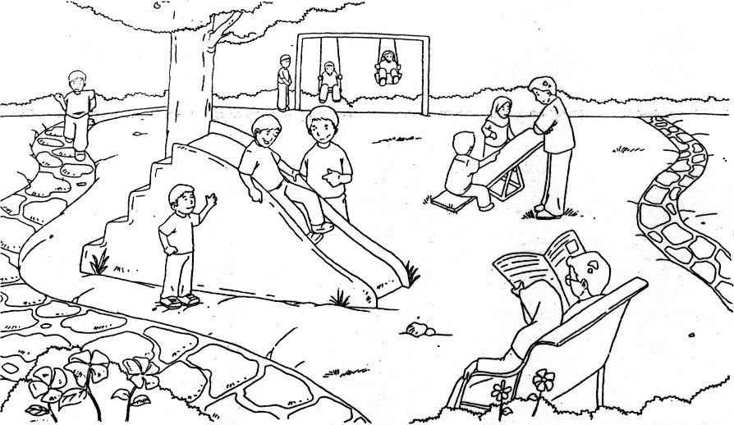

people-park

park – big-clean

8. little boy - standing

5. two people - sitting

7. many children - park

6. park – clean- tidy

B. Use the words listed above to form simple sentences in the table given to describe the picture

Subject | Verb | Object/Complement
Who | Do/does what | What where how when
1. A boy  2. A boy  3. Two girls  4. A man  5. Two people  6. The park  7. Many children  8. A little boy | ________________  ________________  ________________  ________________  ________________  ________________  ________________  ________________ | ____________________  ____________________  ____________________  ____________________  ____________________  ____________________  ____________________  ____________________

C. Copy the sentences.

1. _________________________________________________________

2. _________________________________________________________

3. _________________________________________________________

4. _________________________________________________________

5. _________________________________________________________

6. ________________________________________________________

7. _________________________________________________________

8. _________________________________________________________

ACTIVITY 3

A. Look at the picture carefully. List down words about the picture (e.g nouns,
verbs).

3. friends - standing
2. children- clapping
1. balloons- hanging

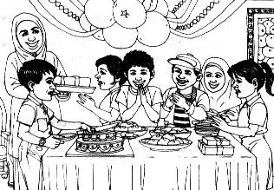

6. Ali - celebrating
4. a few presents - table

5. cake- food- table
7. mother- carrying

8. some children - party

B. Use the words listed above to form simple sentences in the table given to describe the picture.

Subject | verb | Object/ Complement
Who | do/does what | What where how when
1. The balloons  2. __________________  3. Ali’s friends  4. _________________  5. _________________  6. Ali  7. ________________  8. Some children | ________________  are clapping  ________________  are  are  is celebrating  is carrying  __________________ | _______________________  _______________________  _______________________  _______________________  _______________________  _______________________  _______________________  _______________________

C. Copy the sentences.

1. _________________________________________________________

2. _________________________________________________________

3. _________________________________________________________

4. _________________________________________________________

5. _________________________________________________________

6. ________________________________________________________

7. _________________________________________________________

8. _________________________________________________________

ACTIVITY 4

A. Look at the picture carefully. List down words about the picture (e.g nouns,
verbs).

………….. – night market

------------- - making

Pak Ali - …………..

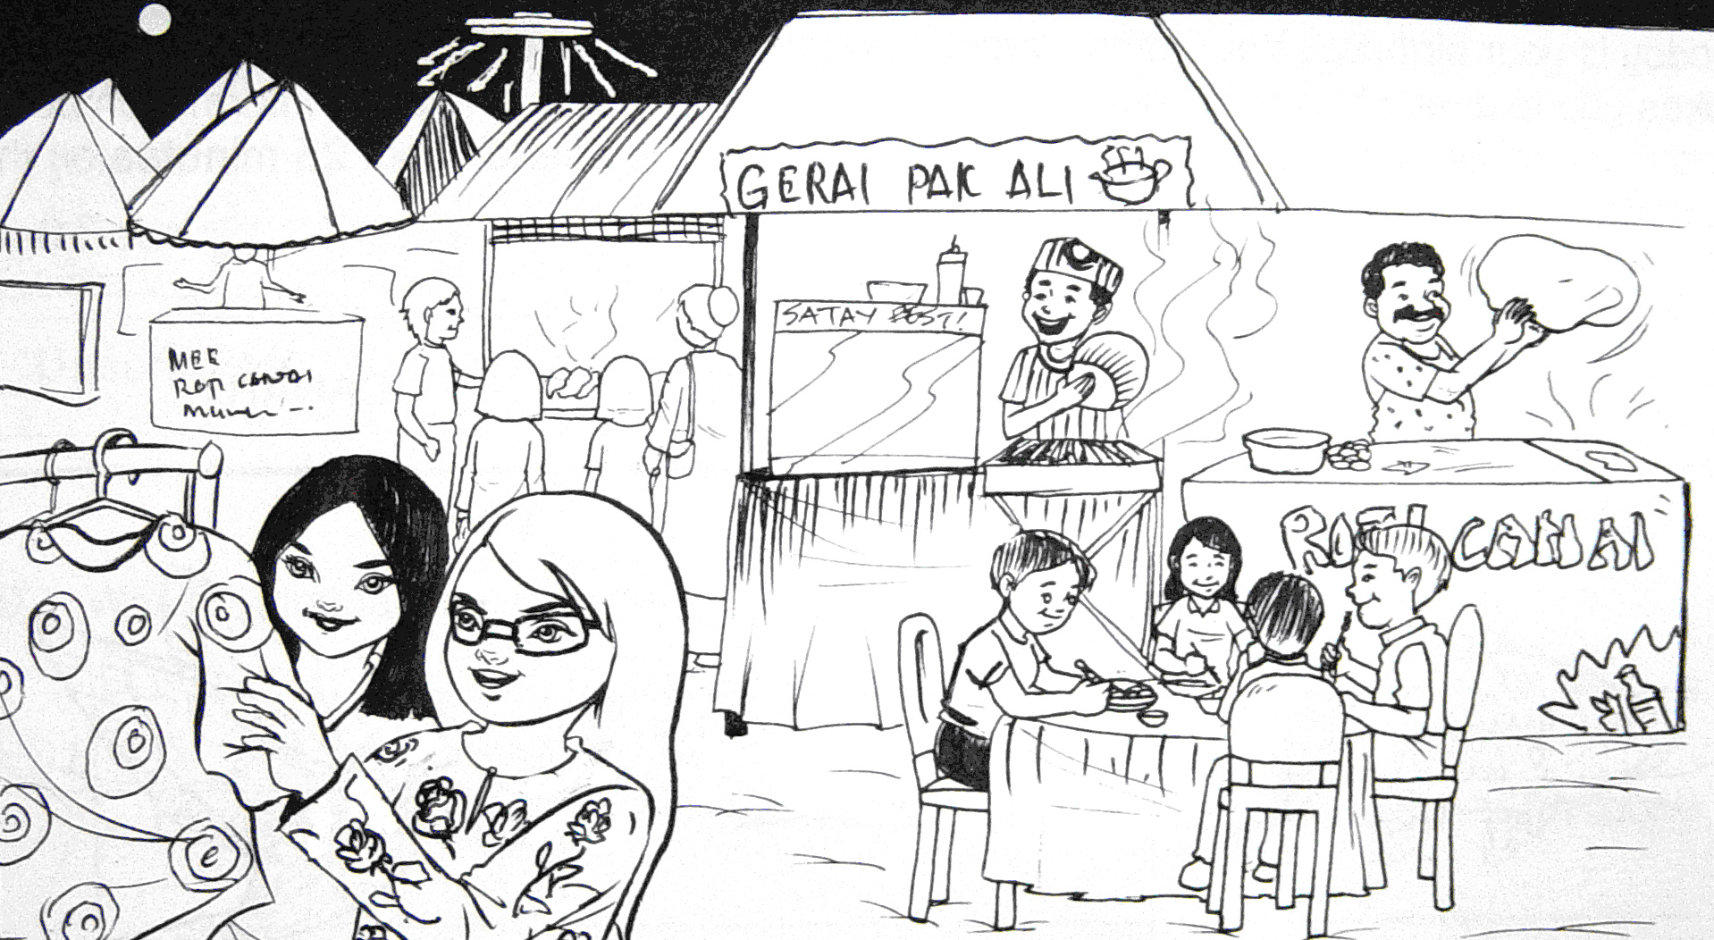

two girls - …………….
children - ………….

………….. - waiting

B. Use the words listed above to form simple sentences in the table given to describe the picture

Subject | verb | Object/ Complement
Who | do/does what | What where how when
1. __________________  2. __________________  3. _________________  4. _________________  5. _________________  6. _________________  7. ________________  8. ________________ | ________________  ________________  ________________  ________________  ________________  ________________  ________________  ________________ | _______________________  _______________________  _______________________  _______________________  _______________________  _______________________  _______________________  _______________________

C. Copy the sentences.

1. _________________________________________________________

2. _________________________________________________________

3. _________________________________________________________

4. _________________________________________________________

5. _________________________________________________________

6. ________________________________________________________

7. _________________________________________________________

8. _________________________________________________________

ACTIVITY 5

A. Look at the picture carefully. List down words about the picture (e.g nouns,
verbs).

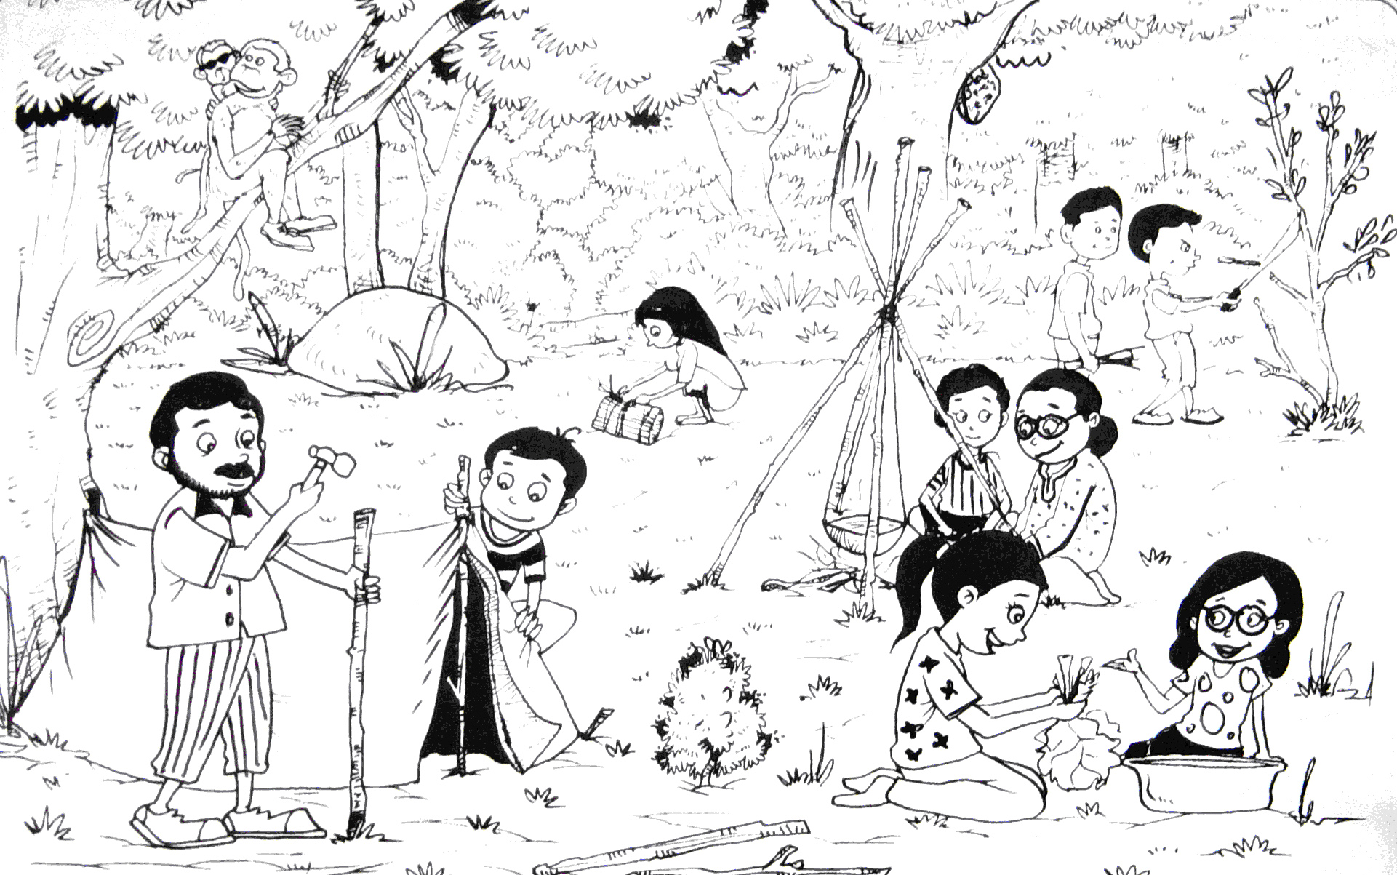

B. Use the words listed above to form simple sentences in the table given to describe the picture

Subject | verb | Object/ Complement
Who | do/does what | What where how when
1. __________________  2. __________________  3. __________________  4. _________________  5. _________________  6. _________________  7. _________________  8. _________________ | ___________________  ___________________  ____________________  ____________________  ____________________  ____________________  ____________________  ____________________ | _______________________  _______________________  _______________________  _______________________  _______________________  _______________________  _______________________  _______________________

C. Copy the sentences.

1. _________________________________________________________

2. _________________________________________________________

3. _________________________________________________________

4. _________________________________________________________

5. _________________________________________________________

6. ________________________________________________________

7. _________________________________________________________

8. _________________________________________________________

ACTIVITY 6

A. Look at the picture carefully. List down words about the picture (e.g nouns,
verbs).

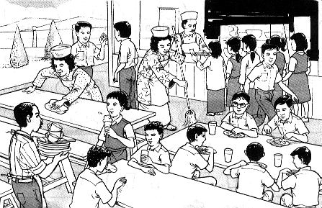

B. Use the words listed above to form simple sentences in the table given to describe the picture.

Subject | verb | Complement
Who | do/does what | What where how when
1. __________________  2. __________________  3. __________________  4. _________________  5. _________________  6. _________________  7. _________________  8. _________________ | ___________________  ___________________  ____________________  ____________________  ____________________  ____________________  ____________________  ____________________ | _______________________  _______________________  _______________________  _______________________  _______________________  _______________________  _______________________  _______________________

C. Copy the sentences.

1. _________________________________________________________

2. _________________________________________________________

3. _________________________________________________________

4. _________________________________________________________

5. _________________________________________________________

6. ________________________________________________________

7. _________________________________________________________

8. _________________________________________________________

ACTIVITY 7

A. Look at the picture carefully. List down words about the picture (e.g nouns,
verbs).

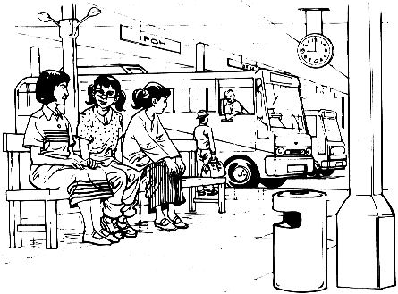

B. Use the words listed above to form simple sentences in the table given to describe the picture

Subject | verb | Object/Complement
Who | do/does what | What where how when
1. __________________  2. __________________  3. __________________  4. _________________  5. _________________  6. _________________  7. _________________  8. _________________ | ___________________  ___________________  ____________________  ____________________  ____________________  ____________________  ____________________  ____________________ | _______________________  _______________________  _______________________  _______________________  _______________________  _______________________  _______________________  _______________________

C. Copy the sentences.

1. _________________________________________________________

2. _________________________________________________________

3. _________________________________________________________

4. _________________________________________________________

5. _________________________________________________________

6. ________________________________________________________

7. _________________________________________________________

8. _________________________________________________________

ACTIVITY 8

A. Look at the picture carefully. List down words about the picture (e.g nouns,
verbs) .

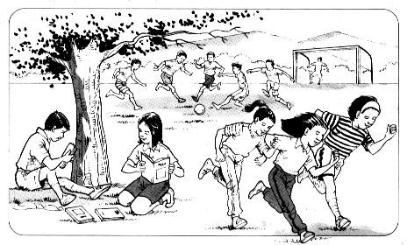

B. Use the words listed above to form simple sentences in the table given to describe the picture

Subject | verb | Object/ Complement
Who | do/does what | What where how when
1. __________________  2. __________________  3. __________________  4. _________________  5. _________________  6. _________________  7. _________________  8. _________________ | ___________________  ___________________  ____________________  ____________________  ____________________  ____________________  ____________________  ____________________ | _______________________  _______________________  _______________________  _______________________  _______________________  _______________________  _______________________  _______________________

C. Copy the sentences.

1. _________________________________________________________

2. _________________________________________________________

3. _________________________________________________________

4. _________________________________________________________

5. _________________________________________________________

6. ________________________________________________________

7. _________________________________________________________

8. _________________________________________________________

ACTIVITY 9

A. Look at the picture carefully. List down words about the picture (e.g nouns,
verbs) .

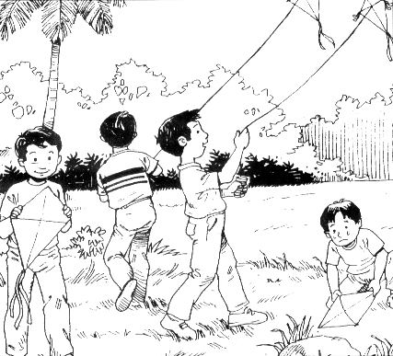

B. Use the words listed above to form simple sentences in the table given to describe the picture

Subject | verb | Object/ Complement
Who | do/does what | What where how when
1. __________________  2. __________________  3. __________________  4. _________________  5. _________________  6. _________________  7. _________________  8. _________________ | ___________________  ___________________  ____________________  ____________________  ____________________  ____________________  ____________________  ____________________ | _______________________  _______________________  _______________________  _______________________  _______________________  _______________________  _______________________  _______________________

C. Copy the sentences.

1. _________________________________________________________

2. _________________________________________________________

3. _________________________________________________________

4. _________________________________________________________

5. _________________________________________________________

6. ________________________________________________________

7. _________________________________________________________

8. _________________________________________________________

ACTIVITY 10

A. Look at the picture carefully. List down words about the picture (e.g nouns,
verbs) .

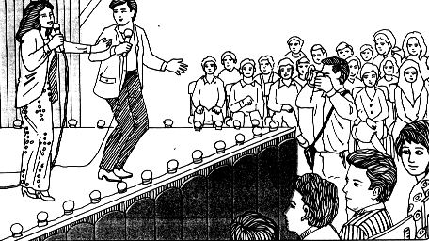

B. Use the words listed above to form simple sentences in the table given to describe the picture

Subject | verb | Object/ Complement
Who | do/does what | What where how when
1. __________________  2. __________________  3. __________________  4. _________________  5. _________________  6. _________________  7. _________________  8. _________________ | ___________________  ___________________  ____________________  ____________________  ____________________  ____________________  ____________________  ____________________ | _______________________  _______________________  _______________________  _______________________  _______________________  _______________________  _______________________  _______________________

C. Copy the sentences.

1. _________________________________________________________

2. _________________________________________________________

3. _________________________________________________________

4. _________________________________________________________

5. _________________________________________________________

6. ________________________________________________________

7. _________________________________________________________

8. _________________________________________________________

ACTIVITY 11

A. Look at the picture carefully. List down words about the picture (e.g nouns,
verbs) .

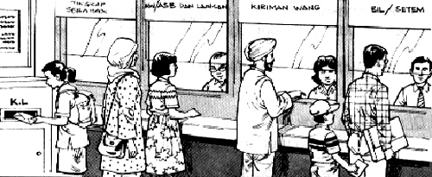

B. Use the words listed above to form simple sentences in the table given to describe the picture

Subject | verb | Object/ Complement
Who | do/does what | What where how when
1. __________________  2. __________________  3. __________________  4. _________________  5. _________________  6. _________________  7. _________________  8. _________________ | ___________________  ___________________  ____________________  ____________________  ____________________  ____________________  ____________________  ____________________ | _______________________  _______________________  _______________________  _______________________  _______________________  _______________________  _______________________  _______________________

C. Copy the sentences.

1. _________________________________________________________

2. _________________________________________________________

3. _________________________________________________________

4. _________________________________________________________

5. _________________________________________________________

6. ________________________________________________________

7. _________________________________________________________

8. _________________________________________________________

ACTIVITY 12

A. Look at the picture carefully. List down words about the picture (e.g nouns,
verbs) .

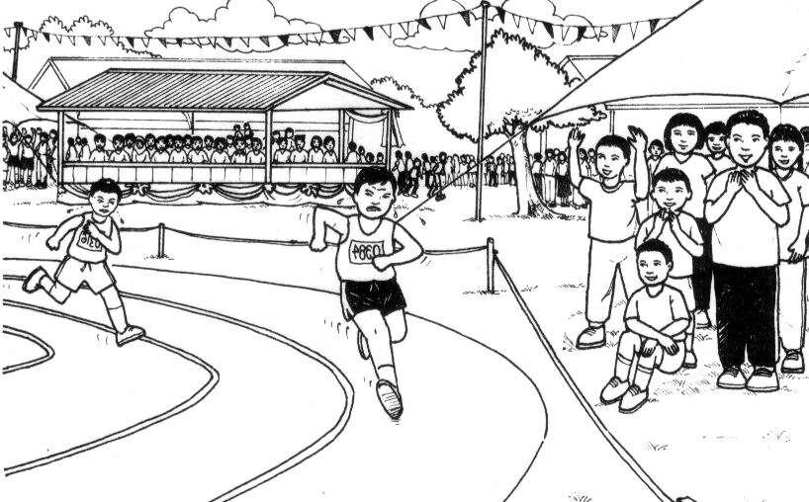

B. Use the words listed above to form simple sentences in the table given to describe the picture

Subject | verb | Object/ Complement
Who | do/does what | What where how when
1. __________________  2. __________________  3. __________________  4. _________________  5. _________________  6. _________________  7. _________________  8. _________________ | ___________________  ___________________  ____________________  ____________________  ____________________  ____________________  ____________________  ____________________ | _______________________  _______________________  _______________________  _______________________  _______________________  _______________________  _______________________  _______________________

C. Copy the sentences.

1. _________________________________________________________

2. _________________________________________________________

3. _________________________________________________________

4. _________________________________________________________

5. _________________________________________________________

6. ________________________________________________________

7. _________________________________________________________

8. _________________________________________________________

ACTIVITY 13

A. Look at the picture carefully. List down words about the picture (e.g nouns,
verbs) .

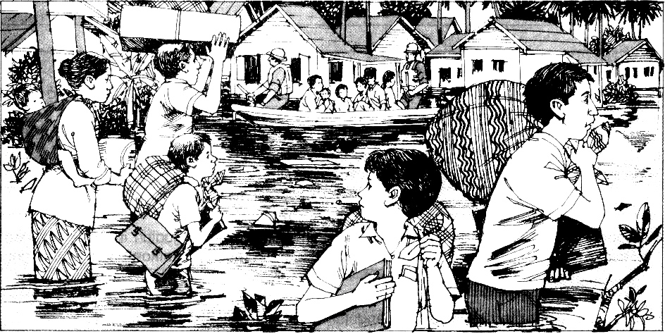

B. Use the words listed above to form simple sentences in the table given to describe the picture

Subject | verb | Object/ Complement
Who | do/does what | What where how when
1. __________________  2. __________________  3. __________________  4. _________________  5. _________________  6. _________________  7. _________________  8. _________________ | ___________________  ___________________  ____________________  ____________________  ____________________  ____________________  ____________________  ____________________ | _______________________  _______________________  _______________________  _______________________  _______________________  _______________________  _______________________  _______________________

C. Copy the sentences.

1. _________________________________________________________

2. _________________________________________________________

3. _________________________________________________________

4. _________________________________________________________

5. _________________________________________________________

6. ________________________________________________________

7. _________________________________________________________

8. _________________________________________________________

ACTIVITY 14

A. Look at the picture carefully. List down words about the picture (e.g nouns,
verbs) .

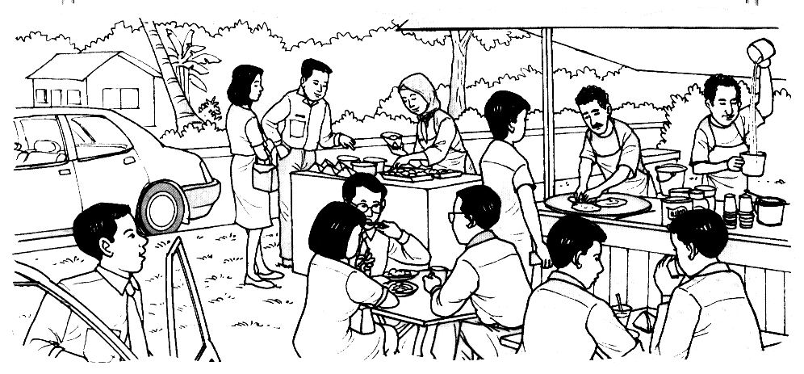

B. Use the words listed above to form simple sentences in the table given to describe the picture

Subject | verb | Object/ Complement
Who | do/does what | What where how when
1. __________________  2. __________________  3. __________________  4. _________________  5. _________________  6. _________________  7. _________________  8. _________________ | ___________________  ___________________  ____________________  ____________________  ____________________  ____________________  ____________________  ____________________ | _______________________  _______________________  _______________________  _______________________  _______________________  _______________________  _______________________  _______________________

C. Copy the sentences.

1. _________________________________________________________

2. _________________________________________________________

3. _________________________________________________________

4. _________________________________________________________

5. _________________________________________________________

6. ________________________________________________________

7. _________________________________________________________

8. _________________________________________________________

ACTIVITY 15

A. Look at the picture carefully. List down words about the picture (e.g nouns,
verbs) .

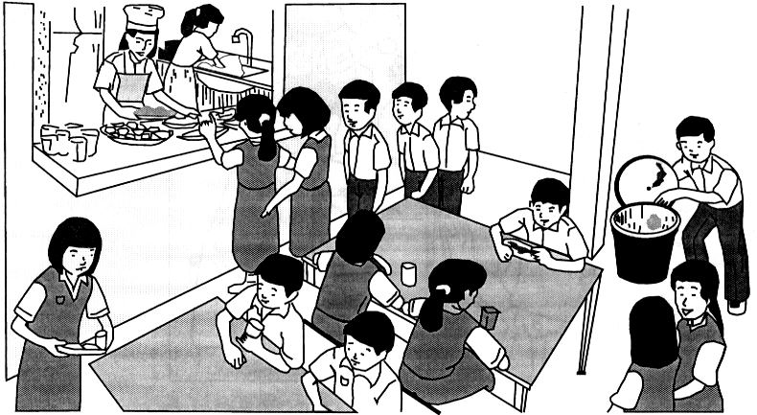

B. Use the words listed above to form simple sentences in the table given to describe the picture

Subject | verb | Object/ Complement
Who | do/does what | What where how when
1. __________________  2. __________________  3. __________________  4. _________________  5. _________________  6. _________________  7. _________________  8. _________________ | ___________________  ___________________  ____________________  ____________________  ____________________  ____________________  ____________________  ____________________ | _______________________  _______________________  _______________________  _______________________  _______________________  _______________________  _______________________  _______________________

C. Copy the sentences.

1. _________________________________________________________

2. _________________________________________________________

3. _________________________________________________________

4. _________________________________________________________

5. _________________________________________________________

6. ________________________________________________________

7. _________________________________________________________

8. _________________________________________________________

ACTIVITY 16

Look at the picture carefully. Write five sentences about it. You may use the words in the boxes to help you.

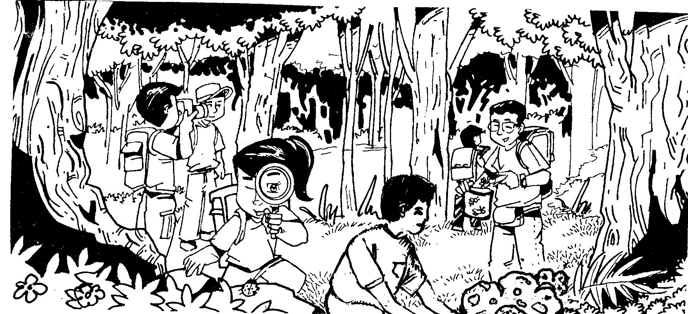

scenery
looking
ladybird
insects
container
jungle
project
observing
photographs
Rafflesia

1. ____________________________________________________________________

____________________________________________________________________

2. ____________________________________________________________________
____________________________________________________________________

3. ____________________________________________________________________

____________________________________________________________________

4. ____________________________________________________________________

____________________________________________________________________

5. ____________________________________________________________________

____________________________________________________________________

ACTIVITY 17

Look at the picture carefully. Write five sentences about it. You may use the words in the boxes to help you.

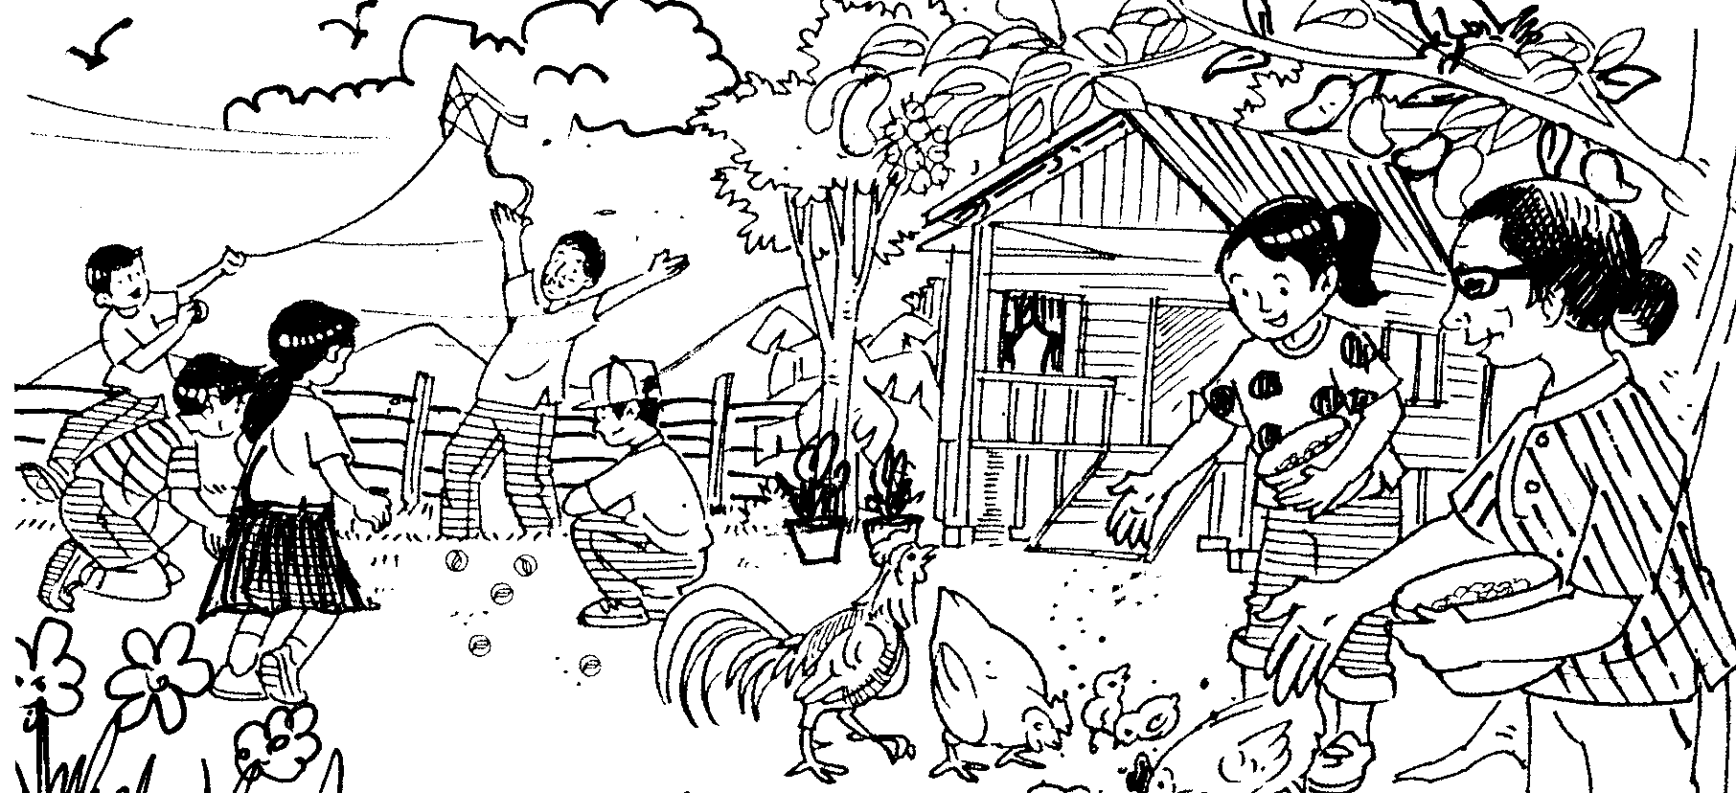

kite
playing
marbles
outside
wooden
daughter
feeding
grains
tree
perching

1. ____________________________________________________________________

____________________________________________________________________

2. ____________________________________________________________________
____________________________________________________________________

3. ____________________________________________________________________

____________________________________________________________________

4. ____________________________________________________________________

____________________________________________________________________

5. ____________________________________________________________________

____________________________________________________________________

ACTIVITY 18

Look at the picture carefully. Write five sentences about it. You may use the words in the boxes to help you.
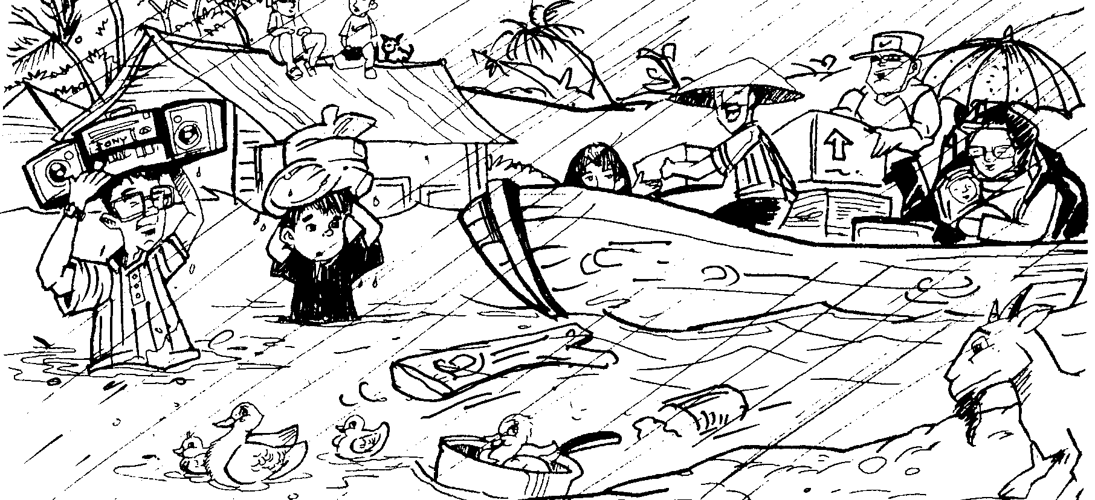

help
duck
swimming
safer
boat
evacuating
flooded
bundle
roof
head

1. ____________________________________________________________________

____________________________________________________________________

2. ____________________________________________________________________
____________________________________________________________________

3. ____________________________________________________________________

____________________________________________________________________

4. ____________________________________________________________________

____________________________________________________________________

5. ____________________________________________________________________

____________________________________________________________________

ACTIVITY 19

Look at the picture carefully. Write five sentences about it. You may use the words in the boxes to help you.
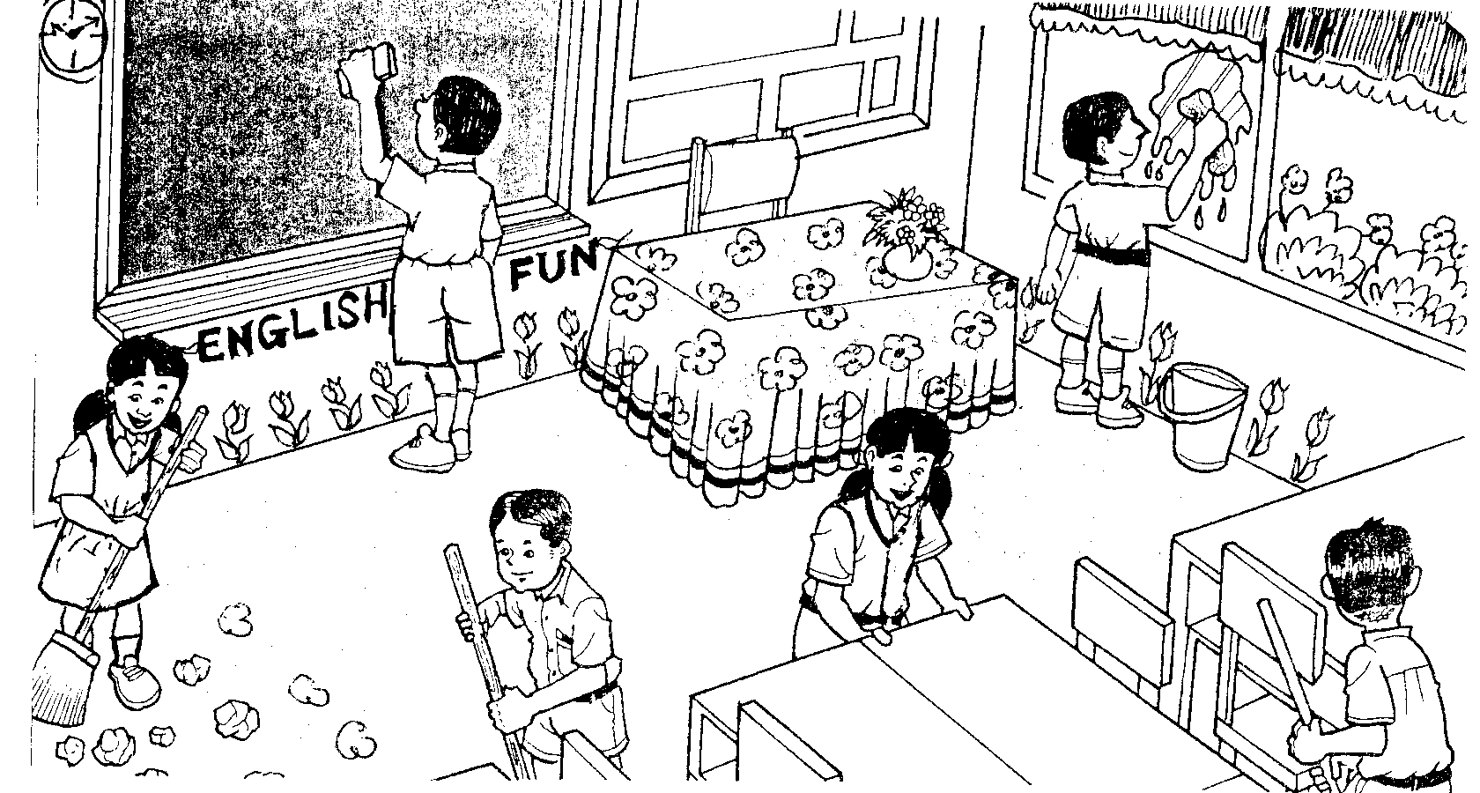

arranging
window
cloth
enjoy
duties
classroom
sweeping
floor
duster
cleaning

1. ____________________________________________________________________

____________________________________________________________________

2. ____________________________________________________________________
____________________________________________________________________

3. ____________________________________________________________________

____________________________________________________________________

4. ____________________________________________________________________

____________________________________________________________________

5. ____________________________________________________________________

____________________________________________________________________

ACTIVITY 20

Look at the picture carefully. Write five sentences about it. You may use the words in the boxes to help you.
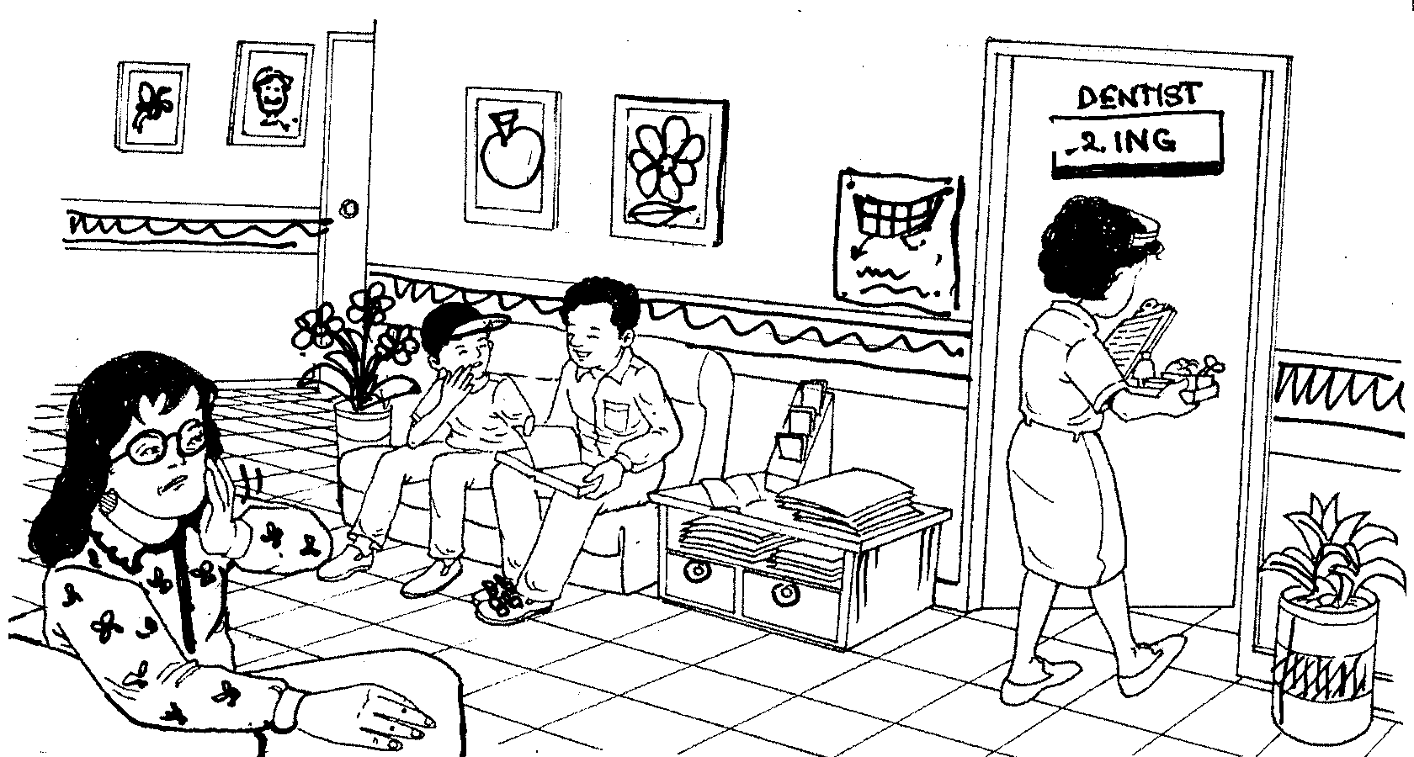

magazines
table
patients
waiting
turns
dental
carrying
files
toothache
woman

1. ____________________________________________________________________

____________________________________________________________________

2. ____________________________________________________________________
____________________________________________________________________

3. ____________________________________________________________________

____________________________________________________________________

4. ____________________________________________________________________

____________________________________________________________________

5. ____________________________________________________________________

____________________________________________________________________

ACTIVITY 21

Look at the picture carefully. Write five sentences about it. You may use the words in the boxes to help you.
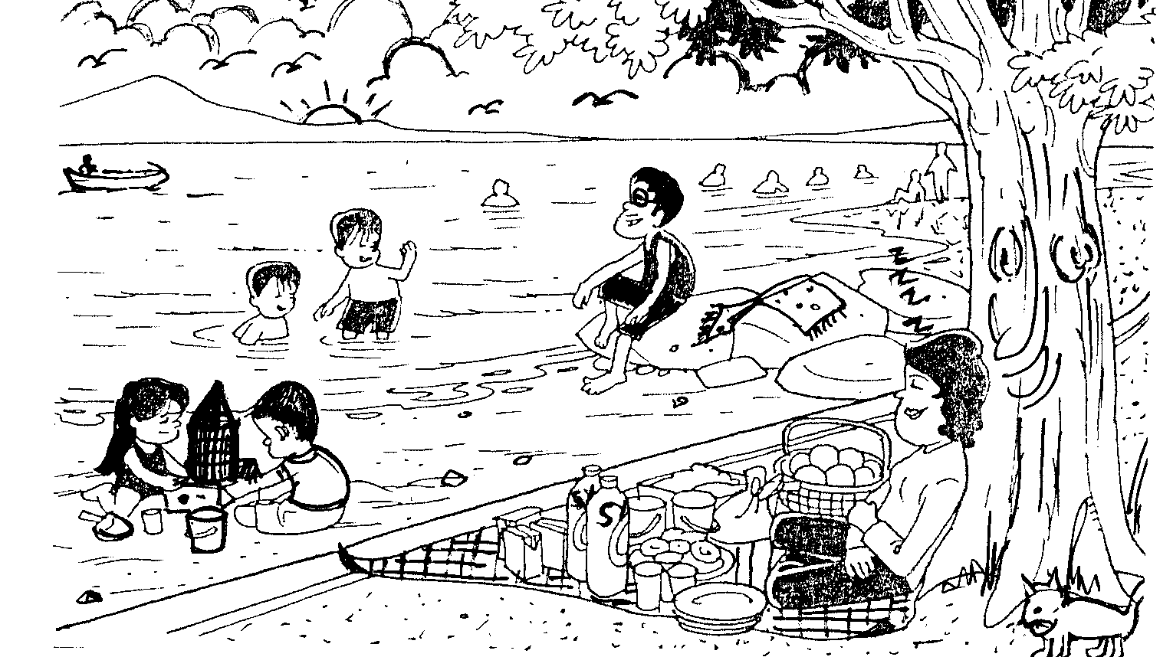

rock
children
playing
water
resting
woman
beach
enjoying
sandcastle
building

1. ____________________________________________________________________

____________________________________________________________________

2. ____________________________________________________________________
____________________________________________________________________

3. ____________________________________________________________________

____________________________________________________________________

4. ____________________________________________________________________

____________________________________________________________________

5. ____________________________________________________________________

____________________________________________________________________

ACTIVITY 22

Look at the picture carefully. Write five sentences about it. You may use the words in the boxes to help you.
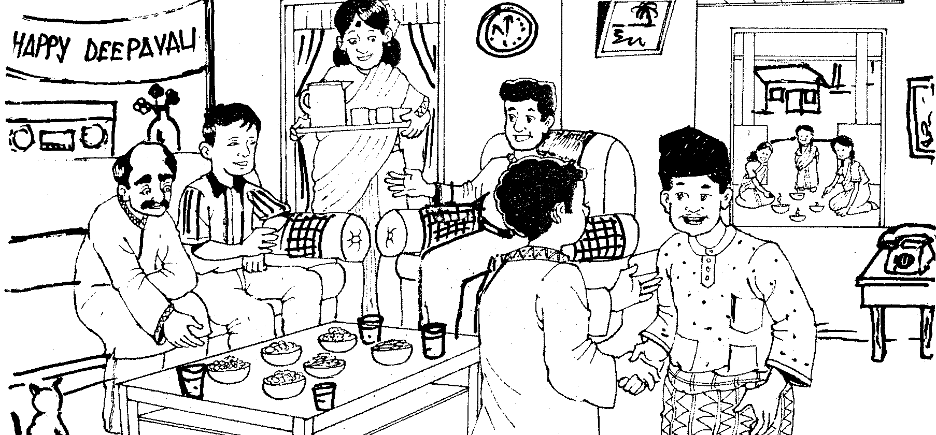

oil lamps
in front
greet
enjoys
Deepavali
celebrating
serving
drinks
lighting
guests

1. ____________________________________________________________________

____________________________________________________________________

2. ____________________________________________________________________
____________________________________________________________________

3. ____________________________________________________________________

____________________________________________________________________

4. ____________________________________________________________________

____________________________________________________________________

5. ____________________________________________________________________

____________________________________________________________________

ACTIVITY 23

Look at the picture carefully. Write five sentences about it. You may use the words in the boxes to help you.
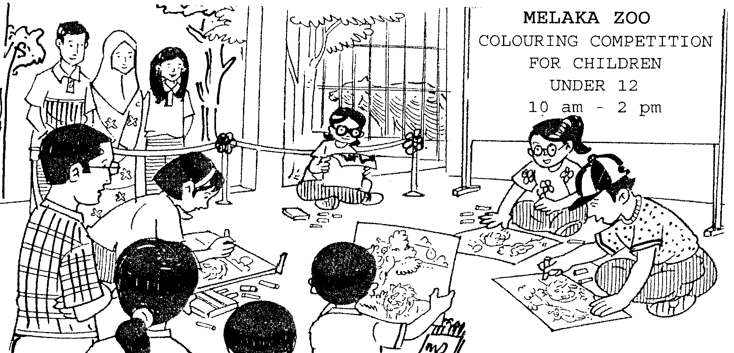

colour
pictures
parents
watching
started
competition
held
children
using
participated

1. ____________________________________________________________________

____________________________________________________________________

2. ____________________________________________________________________
____________________________________________________________________

3. ____________________________________________________________________

____________________________________________________________________

4. ____________________________________________________________________

____________________________________________________________________

5. ____________________________________________________________________

____________________________________________________________________

ACTIVITY 24

Look at the picture carefully. Write five sentences about it. You may use the words in the boxes to help you.
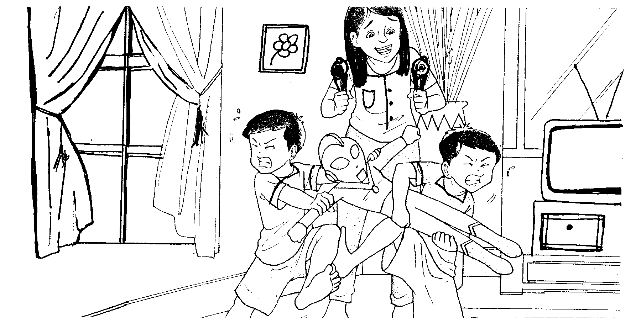

trying
stop
offering
ice-cream
pacify
fighting
toy
boys
twins
living room

1. ____________________________________________________________________

____________________________________________________________________

2. ____________________________________________________________________
____________________________________________________________________

3. ____________________________________________________________________

____________________________________________________________________

4. ____________________________________________________________________

____________________________________________________________________

5. ____________________________________________________________________

____________________________________________________________________

ACTIVITY 25

Look at the picture carefully. Write five sentences about it. You may use the words in the boxes to help you.
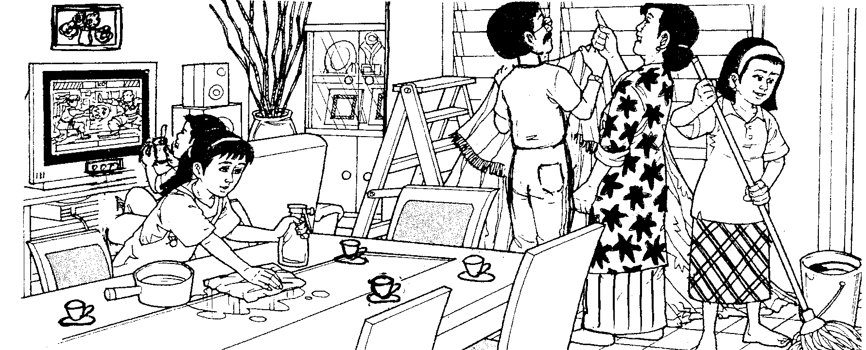

piece
cloth
table
drink
watching
mother
hang
curtain
floor
mopping

1. ____________________________________________________________________

____________________________________________________________________

2. ____________________________________________________________________
____________________________________________________________________

3. ____________________________________________________________________

____________________________________________________________________

4. ____________________________________________________________________

____________________________________________________________________

5. ____________________________________________________________________

____________________________________________________________________

ACTIVITY 26

Look at the picture carefully. Write five sentences about it. You may use the words in the boxes to help you.
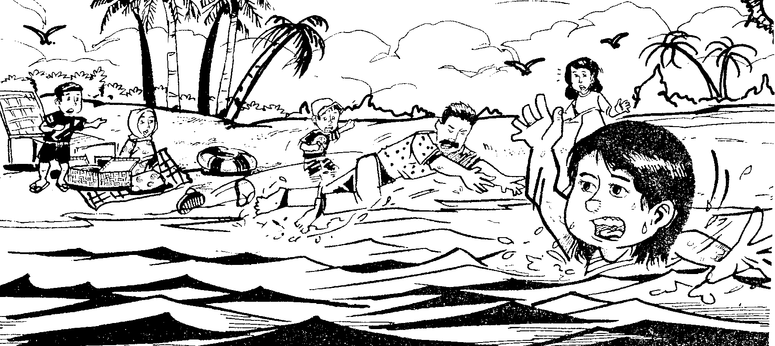

save
boys
pointing
woman
mat
picnic
beach
drowning
into
water

1. ____________________________________________________________________

____________________________________________________________________

2. ____________________________________________________________________
____________________________________________________________________

3. ____________________________________________________________________

____________________________________________________________________

4. ____________________________________________________________________

____________________________________________________________________

5. ____________________________________________________________________

____________________________________________________________________

ACTIVITY 27

Look at the picture carefully. Write five sentences about it. You may use the words in the boxes to help you.
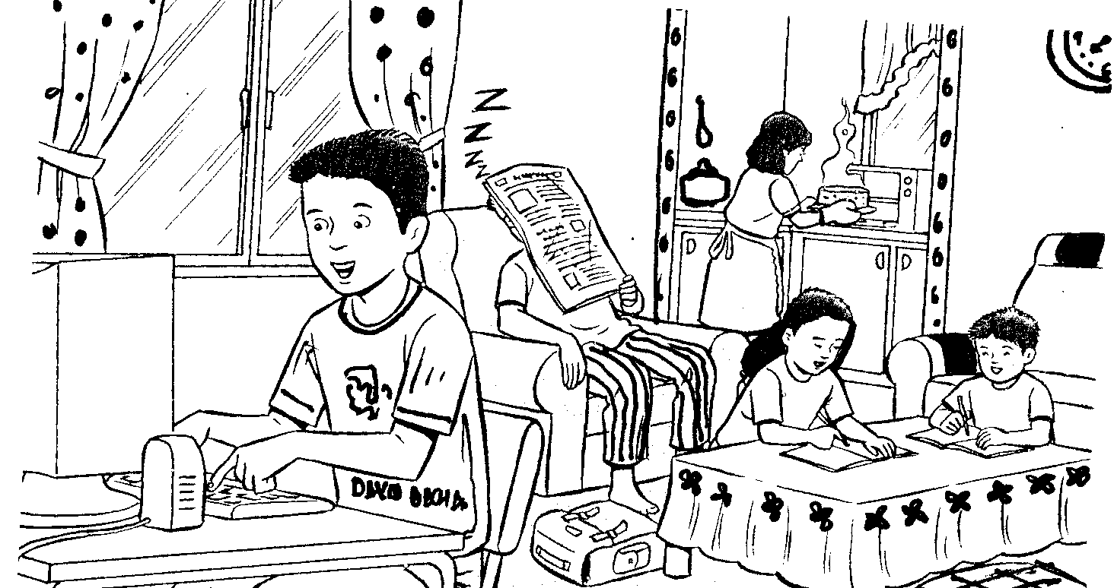

kitchen
man
newspaper
sleeping
work
living room
doing
homework
cake
taking

1. ____________________________________________________________________

____________________________________________________________________

2. ____________________________________________________________________
____________________________________________________________________

3. ____________________________________________________________________

____________________________________________________________________

4. ____________________________________________________________________

____________________________________________________________________

5. ____________________________________________________________________

____________________________________________________________________

ACTIVITY 28

Look at the picture carefully. Write five sentences about it. You may use the words in the boxes to help you.
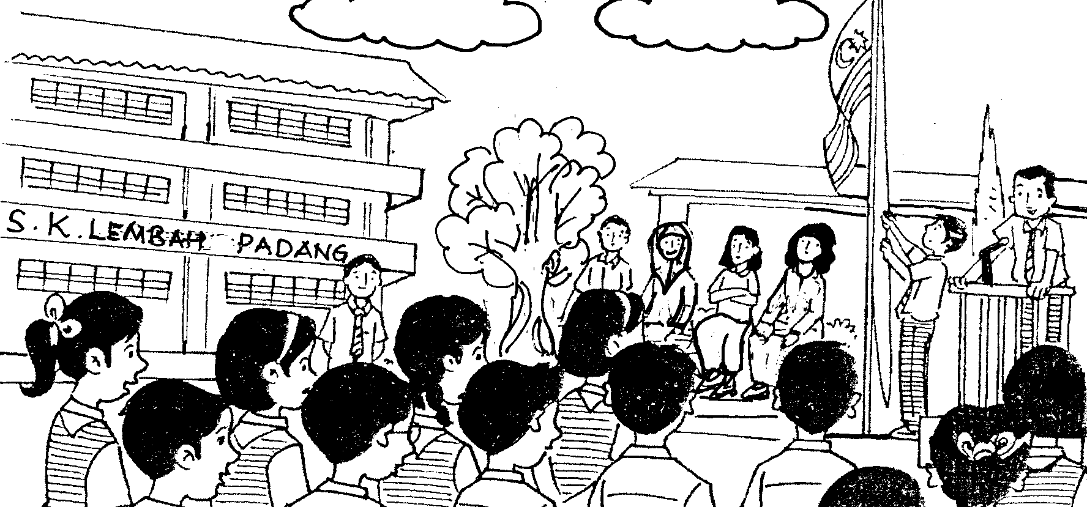

Anthem
duty
raise
flag
announcements
having
assembly
stage
sing
line up

1. ____________________________________________________________________

____________________________________________________________________

2. ____________________________________________________________________
____________________________________________________________________

3. ____________________________________________________________________

____________________________________________________________________

4. ____________________________________________________________________

____________________________________________________________________

5. ____________________________________________________________________

____________________________________________________________________

ACTIVITY 29

Look at the picture carefully. Write five sentences about it. You may use the words in the boxes to help you.
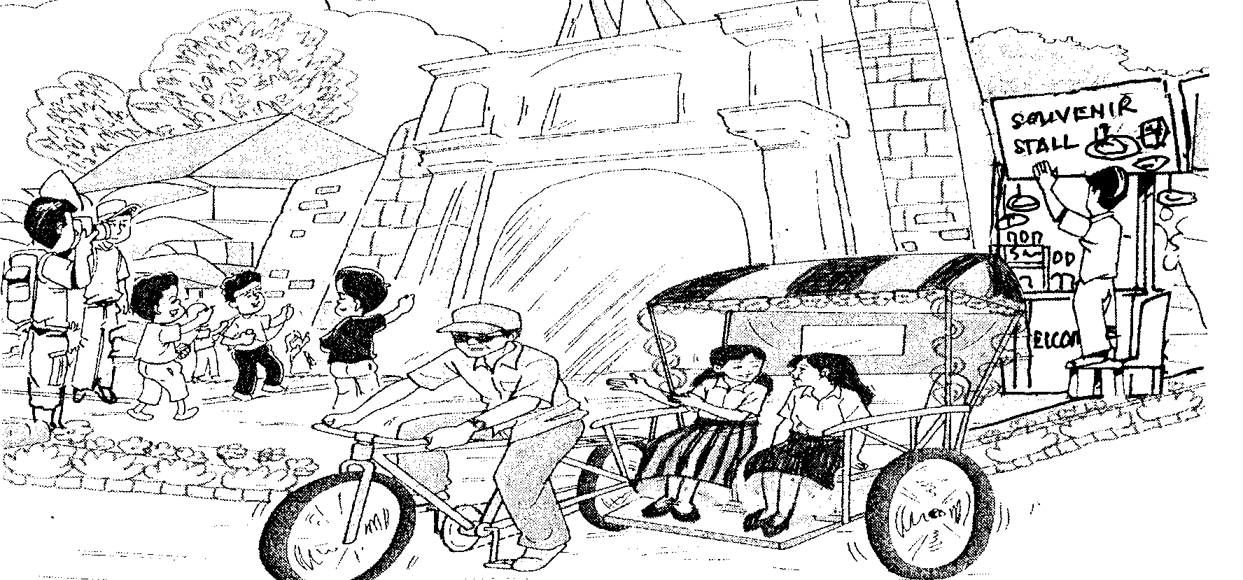

photographs
eager
building
historical
souvenirs
tourists
A Famosa
ride
stall
trishaw

1. ____________________________________________________________________

____________________________________________________________________

2. ____________________________________________________________________
____________________________________________________________________

3. ____________________________________________________________________

____________________________________________________________________

4. ____________________________________________________________________

____________________________________________________________________

5. ____________________________________________________________________

____________________________________________________________________

ACTIVITY 30

Look at the picture carefully. Write five sentences about it. You may use the words in the boxes to help you.

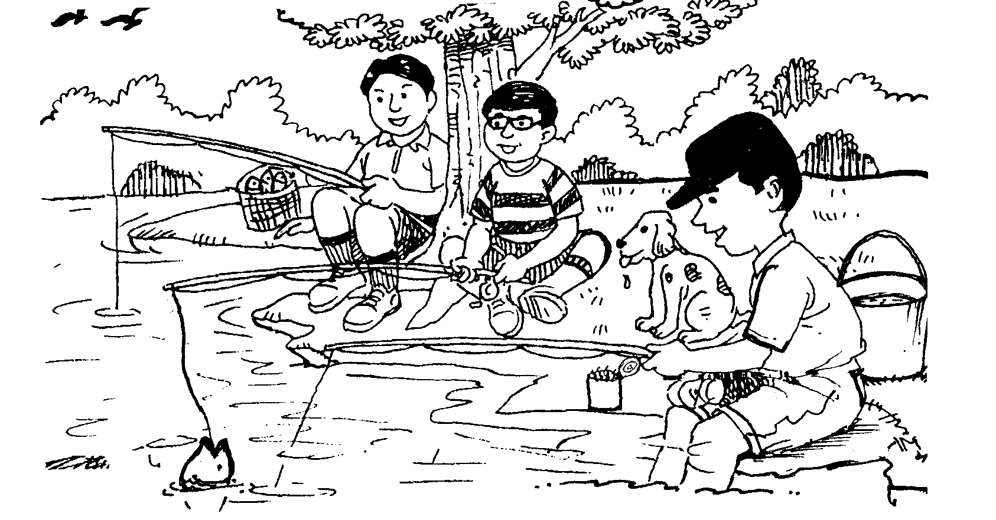

use
rods
put
catch
big
fishing
dog
between
river
basket

1. ____________________________________________________________________

____________________________________________________________________

2. ____________________________________________________________________
____________________________________________________________________

3. ____________________________________________________________________

____________________________________________________________________

4. ____________________________________________________________________

____________________________________________________________________

5. ____________________________________________________________________

____________________________________________________________________

